Architecture Solution Design

Aperture Data Studio Solution Design
[RITM1449981 | ACBSD-4801]
Change Type: [Major]
Planned Deployment Date: [yyyy/mm/dd]

Version Control
Version Control |  |  |  |  | Approvals
Version | Date | Author/  Updated By: | Status | Comment | Pre-ARB | GTS ARB | Global ARB | GITB
01.00.00 | 2026-05-29 | Mohamed Kerbachi | Initial Document |  | ☐ | ☐ | ☐ | ☐
 |  |  | Choose an item. |  | ☐ | ☐ | ☐ | ☐
 |  |  | Choose an item. |  | ☐ | ☐ | ☐ | ☐
 |  |  | Choose an item. |  | ☐ | ☐ | ☐ | ☐
 |  |  | Choose an item. |  | ☐ | ☐ | ☐ | ☐
 |  |  | Choose an item. |  | ☐ | ☐ | ☐ | ☐
 |  |  | Choose an item. |  | ☐ | ☐ | ☐ | ☐

Table of Contents
Version Control 2
Table of Contents 3
1. Distribution and Contacts 5
2. Artifacts 6
3. Summary 7
3.1 Background and Objectives 7
3.2 Business case : Problem Statement & Promise of Value 7
3.3 Business Unit(s) Impacted 7
3.4 Enterprise Architecture Classification 7
3.5 TA Line of Business Sponsor 8
3.6 Solution Overview 8
3.7 SDLC Alignment 8
4. Requirements 9
4.1 Use Cases 9
4.2 Functional Requirements 10
4.3 Non-Functional Requirements 10
4.4 Security Requirements 11
4.5 Data Requirements 11
4.6 Capability Map 11
5. Architecture 12
5.1 Alignment to Principles 12
5.2 Baseline Architecture 14
5.3 Target Architecture 15
5.4 SDLC Component and Architecture Impact 17
6. Components 18
6.1 Components or Patterns Used 18
6.2 Integration Architecture 20
6.3 Data Flow 20
6.4 Data Protection 22
6.5 Observability 22
6.6 Authentication and Authorization 22
6.7 Security Boundaries 22
7. Data Solution 24
7.1 Data Classification 24
7.2 Privacy Impact Assessment (PIA) 24
7.3 Data Encryption 24
7.4 Data Residency 24
8. GenAI 25
9. Free & Open Source Software (FOSS) 26
10. Waivers and/or Exceptions 26
10.1 Risk Acceptances 27
10.2 Risk Remediations 27
10.3 Security Exceptions 27
11. Operational Resiliency 28
12. Exit Strategy 28

Distribution and Contacts
Use confluence link to find contacts for the below section. Delete red text when done.
Link: ISO, DPO and Architects - GTS Architecture Solution Design - Global IT Confluence Production (aegon.com)
This document and future updates to be shared with the business representatives shown below.
Business Contacts and Information
Requester
Business DPO
Business ISO
Business Architect
BCP Manager
Business Unit
Cost Center
Cost Center Owner
Product / Service Owner
ET Global Service Area Contacts and Information
Global DPO | Adam Kaminski & Emma Warner
Global ISO | David Innes, Nick Russell & Daniel Lartey
Global Architecture | Name of Assigned Architect
Global Technology Risk Assessment | Matyas Vajda, Rachel Singewald
GTS/Corp Centre GenAI Working Group | Guy Dye

Artifacts
Review Process and Acknowledgements
In Scope | Owner | Non-Architecture Review / Assessment Process | Point of Contact | Link to Acknowledgement or Evidence
☐ | First Line Risk & Controls | Technology Risk Assessment (only for Core and Common designs) | Rachel Singewald, Matyas Vajda | Link
☐ | Information Security | Information Security Review (process in development and will replace security review section) | David Innes, Nick Russell, Daniel Lartey | Link
☐ | Information Security | Threat Model | Paul Nickelson, Jeff Bain | Link
☐ | Data Privacy | Data Privacy Impact Assessment (OneTrust) | Adam Kaminski | DPIA Number
☐ | Global Architecture | Approved Architectural Artifacts Added to Architecture Repository | Assigned Architect | Link to Repo
☐ | GTS/Corp Centre GenAI | GenAI Inventory & Working Group Communication | Guy Dye | GenAI Inventory ID

Architecture review checklist
Role | Name | Status
Infrastructure Architect |  | Not read
Infrastructure Architect |  | Not read
Enterprise Architect |  | Not read
Solution Architect |  | Not read
Security Architect |  | Not read
Enterprise Technology AI Architecture | Preethi Siddula | Not read

Stakeholders review checklist
Role | Name | Status
Enterprise Technology DPO | Adam Kaminski or Emma Warner | Not read
Enterprise Technology ISO | David Innes or Daniel Lartey | Not read
Enterprise Technology Risk Assessment | Rachel Singewald or Matyas Vajda | Not read
Cloud Infrastructure | Tiffany Boisen or John Hegyi | Not read

Summary

Background and Objectives
Describe the business need, objective, and value for the solution. Describe the relevant drivers and constraints for the solution.
Text

Business case : Problem Statement & Promise of Value
Describe the desired outcome.
Text

Business Unit(s) Impacted
The following Country/Business Unit(s) will be impacted by this Solution Design:
☐ | TA | ☐ | Spain
☐ | UK | ☐ | TLB
☐ | NL (ASR) | ☐ | Corporate Centre
☐ | AAM | ☐ | Other (Specify)
☐ | Enterprise Technology | ☐ | Global

Enterprise Architecture Classification
Enterprise Architecture Classification
☐ | Core: Technology components that are shared by all BUs across the enterprise​
☐ | Common: Technology components shared by multiple business units within the enterprise
☐ | Distinct: Technology components that are specific to a particular business unit within the enterprise​

TA Line of Business Sponsor
TA Line of Business Sponsor
☐ | WFG | ☐ | Corporate Systems & Data | ☐ | Global Technology First Line Risk & Controls
☐ | Savings & Investment | ☐ | ET COO (Portfolio Management, Comms, Vendor/Business Partner Management) | ☐ | Global Sourcing & Procurement
☐ | Protection Solutions, Financial Assets & Operations | ☐ | Global Information Security Services | ☐ | Other [Enter Value]
☐ | Business Emblement Services & Technology | ☐ | Global Architecture & Engineering Enablement

Solution Overview
Describe the desired outcome.
Change Type | [Major or Minor]
Anticipated Planning End Date | yyyy-mm-dd
Anticipated Deployment Date | yyyy-mm-dd

SDLC Alignment
- Types of Software Change Involved in the Solution
☐ | Homegrown Software Development: New SDLC Components / Homegrown software developed in house, packaged, versioned and deployed
☐ | Commercial off the Shelf (COTS) or Open-Source Implementation: Use of new Commercial off the Shelf or Open-Source Software Implementation
☐ | Third Party Integration: Integration of Third-party hosted technology, Software as a Service or Platform as a Service with Aegon software / systems
☐ | None: Not Applicable for this solution

- Software Solution Complexity
☐ | High Complexity: New Software / System / Migration to Third Party Platform or an Architecturally Significant Change
☐ | Medium Complexity: New Feature / Enhancement / Major Version Upgrade or an Architecturally Simple Change
☐ | Low Complexity: Bug Fix / Patch / Minor Version Upgrade / Configuration, Low Code/No Code or No Architecture Change
☐ | None: Not Applicable for this solution

- SDLC Methodologies Used
☐ | Waterfall
☐ | Agile
☐ | Hybrid
☐ | None: Not Applicable for this solution

Requirements

Use Cases
If applicable
Key Objectives
Scope

Use Case Requirements
If applicable, delete if not required. May be covered in 3.1 Use Cases
Goal | Actor(s) | Pre-conditions | Description of how actor achieves goal | Scenario type

Business Requirements
Document business requirements or additional technical requirements that must be accounted for within the solution design. If there are no additional requirements, then state N/A.
MoSCoW based priority.
Must-haves: critical requirements that are essential for the project’s success. These requirements are mandatory and must be included in the project scope.
Should-haves: high-priority features that are not critical to launch.
Could-haves: requirements that are desirable but not necessary.
Won’t-haves: requirements that are not included in the project scope.
Business Requirements
Req. # | Requirement Details | Priority
BR. 1.0 |  | Must Have
BR. 2.0 |  | Should Have
BR. 3.0 |  | Could Have

Functional Requirements
Functional Requirements
Req. # | Req. Category | Requirement Details | Priority
FR.1.0 | Technology component |  | Must Have
FR.2.0 | Segmentation |  | Must Have
FR.3.0 | Security |  | Must Have

Non-Functional Requirements
Non-Functional Requirements
Req. # | Req. Category | Requirement Details | Priority
NFR.1.0 | Observability, Logging and Monitoring Requirements | Define the observability, logging, and monitoring requirements for the solution. If observability, logging, and monitoring requirements are not in scope, then state N/A. | Must Have
NFR.2.0 | Fault Tolerance & Resiliency Requirements | Document the failover, redundancy, high-availability, scalability, backup / recovery, RTO and RPO requirements for the solution. If fault tolerance and resiliency requirements for the solution are not in scope, then state N/A. | Must Have
NFR.3.0 | Availability Objectives | Document the availability objectives for the solution. Availability objectives for current service offerings of GTS are documented here: Availability Objectives. If availability objectives are not in scope, then state N/A. | Must Have
NFR.4.0 | Performance Requirements | Document the performance requirements for the solution. If performance requirements for the solution are not in scope, then state N/A.
NFR.5.0 | Capacity Requirements | Document the capacity requirements for the solution. If capacity requirements are not in scope for the solution, then state N/A.

Security Requirements
Minimum security requirements are defined by the application risk rating (high, medium, low) for technology components identified within Components section.
See Minimum Security Requirements by App Risk Rating - Architecture Requirements.pptx for the minimum security requirements.
Security Requirements
Req. # | Req. Category | Requirement Details | Priority
SR.1.0 | Security Requirement | Define the security requirement of the solution…… | Must Have
SR.2.0

Data Requirements
Data Requirements
Req. # | Req. Category | Requirement Details | Priority
DR.1.0 | Data Requirement | Define the data requirement of the solution…… | Must Have
DR.2.0

Capability Map
Using the ArchiMate Cookbook as a reference, include a business capability map

Architecture

Alignment to Principles
Check to verify alignment to architecture principles. If there is no alignment, then provide a reason. Exceptions should be defined with greater detail.
Architecture Principles (sharepoint.com)
Architecture Principles Alignment |  | Principle Description | Justification for lack of alignment (or a comment)
☐ | Capability Driven | Architectural strategy and design decisions are driven by capabilities and strategic objectives, ensuring that technology serves as a robust enabler of business functionality and growth
☐ | Data as an Asset | Technology must treat data as an asset, enabling robust data architecture to ensure the accuracy, accessibility, security, and compliant use of data across our organization.
☐ | Secure &  Compliant | Our architecture must prioritize security and compliance, ensuring that all systems, applications, and data adhere to the highest standards of protection, privacy, and regulatory requirements.
☐ | Transparent & Measurable | Our architectural designs and technology solutions must be transparent and traceable, allowing the rationale behind every decision to be clearly understood and easily tracked. Additionally, they must be measurable, with established metrics to capture data for informed decision-making. This includes both the architecture itself and the solutions it supports, ensuring comprehensive visibility and accountability throughout.
☐ | Future Fit | Architectural approaches prioritize solutions that are future fit, ensuring that our systems are adaptable and flexible over time.
☐ | Reliable & Scalable | Our architectural components and solutions must be reliable and scalable, fostering trust, security, quality, and resiliency within the technology environment.
☐ | Interoperable & Integrated | Systems, applications, and data must be interoperable, enabling seamless integration.
☐ | Standardized | Commit to the standardization of technologies, platforms, tools, and processes across our organization to ensure consistency, efficiency, and quality in our IT operations and services.
☐ | Value & Cost Oriented | Architectural strategy and designs must prioritize and deliver cost effective, tangible business results, ensuring that every technology initiative and decision directly contributes to our organizational goals and objectives.
☐ | Governed AI  by Design | Architectural approaches must ensure that AI capabilities are designed, implemented, and operated with built‑in governance, transparency, and control, enabling safe, secure, and accountable use of AI across the enterprise.

Baseline Architecture
Brief description the current-state architecture. The focus should be on components changing – could be greenfield. This should include the high level as-is contextual diagram of the current-state. If Greenfield, then N/A.
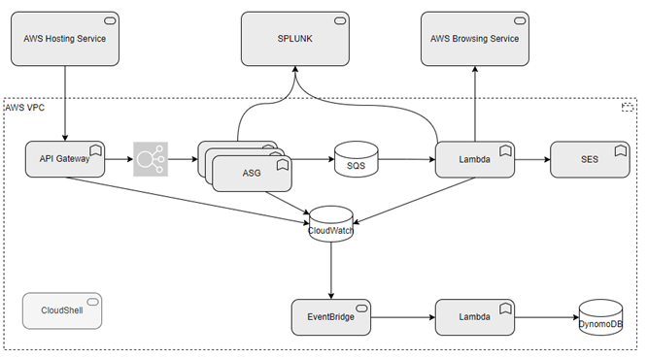

Target Architecture

Overview
Describe the solution at a high level. Describe the changes from the baseline to the target architecture.
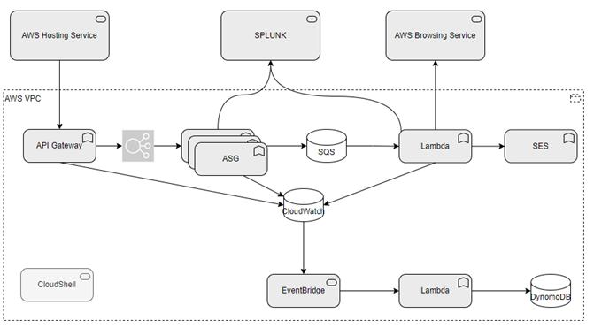

Business Applications & Architecture Impacts
Business Applications represent a high-level abstraction that encapsulates the descriptive metadata and relationships that work together as a technology solution to enable business services, processes and capabilities; Business Applications include homegrown business applications, SaaS or software installed in Data Center or Cloud Infrastructure (e.g., non-desktop software) that independently enable one or more business capabilities, processes, or services.
This is a snapshot of the CI lifecycle and risk rating at the time of the review. Use the NEW EXPERIENCE in ServiceNow for the best experience. The first time you use SN to gather this data, use this link to the CMDB. Open the ‘Update Personalized List’ gear on upper right of the screen. Add the Application IT Compliance and Number (u_ci_id) to your column list. When you find the application you are looking for, select the hyperlinked text under the Application IT Compliance column and NOT the Name column.
Impacted Business Applications |  |  | Architecture Impact | Application IT Compliance Data
CMDB ID  (Link to CMDB Record) | Application Name | Application Business Criticality | Replace, Decom, Migrate, Re-use, Enhance, New | Application Lifecycle Strategy | Regulatory Impacts | App Risk Rating

Gap Analysis
What is changing from Baseline to Target. This is a more detailed description of the changes to the architecture, change in component usage, etc. If Greenfield, then N/A.

SDLC Component and Architecture Impact
SDLC Components of type Application include homegrown, developed software applications, each individually packaged and deployed, that enable functionality for one or more business applications. Examples include domain services, app services, web services, middleware services, backend services, code for data processing batch jobs, or code for data transfer batch jobs.
SDLC Components of type Infrastructure are infrastructure-as-code (IaC) artifacts that define, provision, and configure the runtime environment required for software applications to execute.
SDLC Components are registered into CMDB using this service request form.

Impacted  SDLC Components |  |  |  |  | Architecture Impact | Impacted Business Applications
CMDB ID  (Link to CMDB Record) | SDLC Component  Name | SDLC Type  [application or infrastructure] | Install Type  [on prem, cloud, or hybrid] | Deployment Type  [TA pipeline, Global Pipeline or manual] | Replace, Decom, Migrate, Re-use, Enhance, New | Are business application dependencies mapped to the SDLC Component?

Components

Components or Patterns Used
This will include the logical high-level architecture diagram based on the previous contextual diagram and a list of components used in the solution (use links when possible).
GTS Component Architecture Standards (sharepoint)
GTS Reference Architectures (sharepoint)
GTS Architectural Patterns (sharepoint)
Global Architecture Patterns (sharepoint)

Component Architecture Diagram
Insert the component architecture diagram(s) as needed. This is intended to break down overview diagram when needed and highlight the components and their current use state.
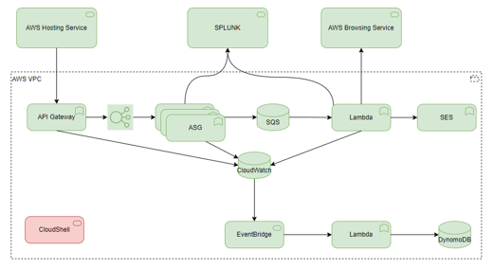

Cloud Service / Components Table
 | AWS or Azure Services / Components |  |  | Architecture Impact
 | Cloud Provider  (AWS or Azure) | Cloud Service / Component  Name | Is Component Standard published in Architecture Repository or is an AWS or Azure service approved for use | Cloud Account(s) where Service / Component will be Deployed | First Time Use In The Enterprise? | First Time Use in Cloud Account?
1
2
3
4
5
6

Integration Architecture
Populate the integration architecture table and provide the integration architecture diagram illustrating the relationships between technology components and the security integration patterns used.

Integration Architecture Diagram
Insert the integration architecture diagram. Include a link to the source file for the diagram for future reference or revisions.
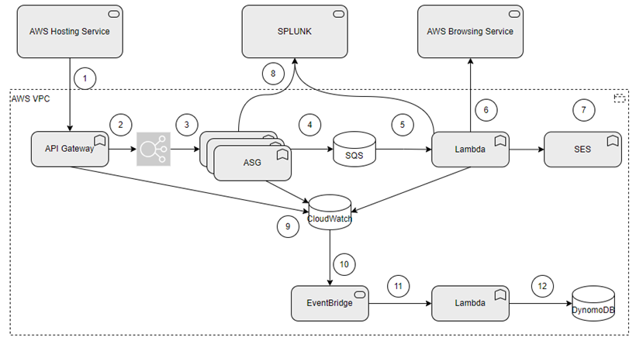

Integration Architecture Table
 | Source  Component | Target  Component | Purpose | Security Integration Pattern Name | Is Pattern Published in  Repository?
1
2
3
4
5
6

Data Flow
Insert the data flow diagram. Include a link to the source file for the diagram for future reference or revisions. If the solution does not include a data flow, insert N/A.

Data Flow Diagram
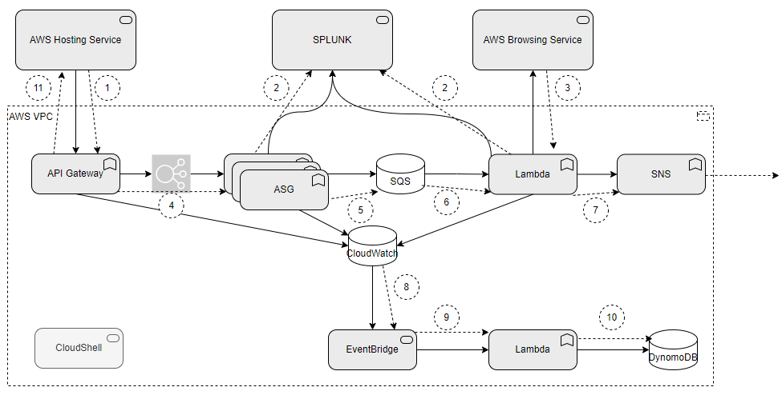

Data Flow Table
 | Source | Target | Sensitive Data? | Data Flow / Data Processing Description
1
2
3
4
5
6
7
8
9

Data Protection
(Tie to Resiliency Matrix) Include Link to Matrix (and the analysis done).
Name the architecture patterns utilized to support fault tolerance & resiliency requirements. If fault tolerance & resiliency patterns are not in scope, then state N/A.

Backup and Recovery
Text

High Availability
Text

Disaster Recovery
Text

Observability
(Tie into Observability patterns\SRE) Include Link to SRE outcome. At a minimum delineate between machine/application events and security events (Splunk)
Text

Authentication and Authorization
Discuss the capabilities of the solution to address authentication and authorization.
Text

Security Boundaries
This section is intended to highlight the security boundaries in the proposed solution. A security boundary is a link between a role\user\system and a component of the proposed solution. In this section the aim is to highlight boundaries in the diagram and capture them, with a short description in the table. Boundaries to existing approved patterns should be highlighted.
The requirement for a threat model assessment will be highlighted during the security review and/or if the Architect has identified significant risk from the identified boundaries in the solution. The use of existing patterns would not normally necessitate a threat model assessment.

Security Boundaries Diagram
Provide a diagram of the security boundaries for assessment by the BU/GTS Security Team.
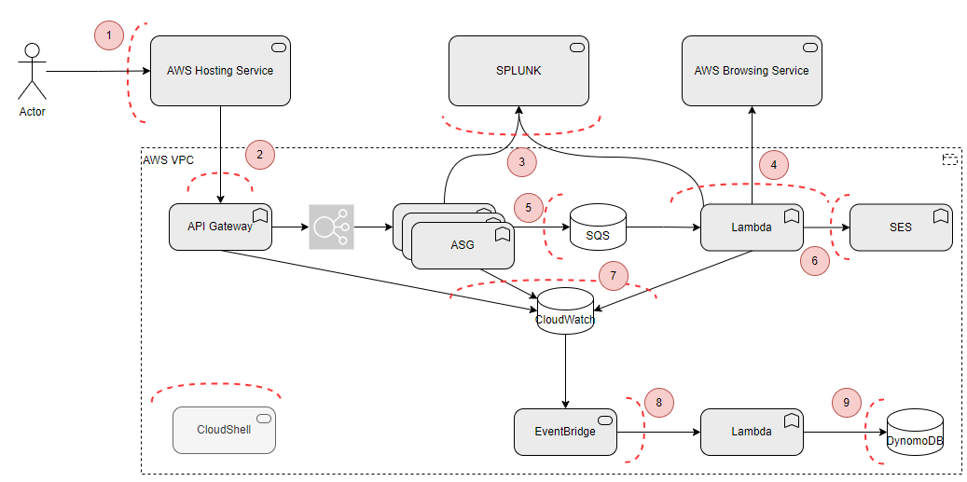

Security Boundaries Table
Security Boundary Reference |  | Existing Pattern | Description
1 | Firewall
2
3
4
5
6

Security Review Outcomes
Detail any significant outcomes, risks or recommendations highlighted in the security review (GTS ISO).
Text

Threat Model Assessment
If a Threat Model Assessment is needed, please complete this section/activity.
Open a Service Request to have a Threat Model Assessment Completed. Include this document and any supporting documented in the service request. After the assessment is complete, return to this document and modify the design/controls/governance to account for proper mitigation of the threats.

Threat Model Assessment Service Request number: XXXXXXXXXX

Data Solution

Data Classification
Make a selection in BOTH columns. Make a selection in BOTH columns.
Data Confidentiality Classification |  |  |  | Data Legal and Regulatory Classification
☐ | Strictly Confidential |  | ☐ |  | Financial Information
☐ | Confidential |  | ☐ |  | Personal Identifiable Information
☐ | Internal |  | ☐ |  | Protected Health Information
☐ | Public |  | ☐ |  | Payment Card Information
☐ | No Data Shared |  | ☐ |  | No Personal Data Shared

Privacy Impact Assessment (PIA)
Work with the Data Officer to assess the potential impact on the privacy of individuals. Include the PIA reference
Text

Data Encryption
Describe the requirements data encryption at rest and in transit. Refer to data security requirements for minimum requirements for data encryption and security. If data is not in scope for the solution, then state N/A.
e.g. Data in transit is being encrypted via SSL TLS1.2 at minimum.
Text

Data Residency
Describe data residency requirements to be considered when architecting the solution. If data residency requirements are not in scope for the solution, then state N/A.
Text

GenAI
Include GenAI inventory number or type type Not applicable.

Aegon GenAI - Home (sharepoint.com)
Gen AI Policy

Does the solution implement or enable Gen AI? | [Yes or No]
Gen AI Use Case ID | [Enter ID # and create hyperlink to the Gen AI Inventory]
Is the Gen AI Use Case Status Approved? | [Yes or No]
Gen AI Risk Rating | [Enter Risk Rating or N/A]

LLM Name | [Enter Name of LLM]
New or Existing | [New or Existing]
If new, LLM Impact Assessment Form | [Enter Link to Completed LLM Impact Assessment]
If new, is LLM Software Acquisition ARB Completed | [Yes or No]
Principle / Requirement | Description | Implementation Responsibility
[Guardrail principle or requirement] | [Describe the configuration to ensure the principle / requirement is addressed by implementations of the LLM/ agents within the solution] | [LLM Gateway or Application]
Repeat the above Table for each LLM. Repeat the last row for each Guardrail for the given LLM

Does the Solution Introduce a new Agent? |  | [Yes or No]
In Scope? | New Agent Type
☐ | Closed Product Agent: Agents embedded inside a product, no extensibility, operate only within that product’s boundary.
☐ | Closed Service (SaaS) Agent: Agents inside third-party SaaS platforms where we cannot control internals.
☐ | Open Product / Open Service Agent: Agents that can call enterprise data, LLMs and APIs. Extendable and orchestratable.
☐ | Home-Grown Enterprise Agent: Agents we fully design and build.

Free & Open Source Software (FOSS)
If the solution design is using FOSS for the first time, complete this section
License and Usage

Software Name: | [Enter Name]
License Category: | [Permissive of Copyleft]
License Name: | [Enter License Name]
Usage | [Internal or Public-Facing]

License Category | License Names | Where It’s Safe to Use | Risks
Permissive | MIT, BSD, Apache 2.0 | ✅ Internal Use  ✅ Public Facing | Low legal risk; no obligation to open-source or share derivative code
Copyleft | GPL v3, LGPL, MPL, AGPL | ⚠️ Internal use only (with caution)  ❌ Public Facing (unless approved) | High risk of IP exposure; can force open sourcing or sharing of proprietary code if solution that leverages the FOSS is public facing

Waivers and/or Exceptions
GTS Architecture Review Board (ARB) provides a governance framework for Architecture Risk. The GTS ARB will review and approve/reject solution Architecture Exceptions.
See this link for documentation related to Exceptions to Standards.
<start of excerpt from the above document>
The GTS ARB holds the responsibility for ensuring that risk acceptances and/or risk remediations for exceptions to standards are approved and documented within architecture templates before granting GTS Final ARB approval. The assigned architect is responsible for memorializing the GTS Risk Acceptances and GTS Risk Remediations within the Waivers and/or Exceptions section of the architecture template that is being presented for GTS ARB approval.
Risk Acceptance and Risk Remediation compliance is a function of the GTS internal risk management process. Exceptions to standards are logged as GTS Risk Acceptances or GTS Risk Remediations.
- GTS Risk Acceptances are logged for exceptions to standards that are not planned to be remediated. GTS Risk Acceptances will be reviewed annually though the GTS first line risk and control process to ensure that the risk acceptance without remediation remains acceptable.
- GTS Risk Remediations are logged for exceptions to standards that are intended to be remediated. Risk remediations require a remediation plan with a remediation date that identifies the commitment to remediate the risk. GTS Risk Remediations are required to be remediated within 12 months.
<end of excerpt from the above document>

Risk Acceptances
# | Acceptance Title | Exception Description | Link to Risk Exception Acceptance
1
2
3

Risk Remediations
# | Remediation Title | Exception Description | Link to Risk Exception Remediation
1
2
3

Security Exceptions
# | Exception Title | Exception Description | Link to Security Exception
1
2
3

Operational Resiliency
 | Operation Resiliency Targets by Tier
 | Tier |  | Tier Name | Purpose
☐ | Tier 0 |  | Core Infrastructure | Supports the most crucial technology infrastructure requiring the highest level of resiliency to operate lower tier infrastructure, business or technology applications
☐ | Tier 1 |  | Mission Critical | Supports business processes or business services classified as Mission Critical within the Business Impact Assessment (BIA) framework
☐ | Tier 2 |  | Business Critical | Supports business processes or business services classified as Business Critical within the Business Impact Assessment (BIA) framework
☐ | Tier 3 |  | Important | Supports business processes or business services classified as Important within the Business Impact Assessment (BIA) framework
☐ | Tier 4 |  | Best Effort | Supports business processes or business services classified as Best Effort within the Business Impact Assessment (BIA) framework
Select one and only one
Include link to the Architecture Resiliency Tier & Design Criteria Assessment

Exit Strategy
Example Exit Plan Components: A robust exit strategy may include:
- Risk Assessment: Identifying risks associated with vendor lock-in and potential exit scenarios.
- Data Migration Plan: Defining how data will be moved to an alternative solution.
- Application Transition: Ensuring applications can function seamlessly in the new environment.
- Contractual Considerations: Reviewing contracts and understanding termination clauses.
- Testing and Validation: Validating the exit plan through testing and simulations.
- Communication Plan: Informing stakeholders about the transition process.
Research and vet alternative solutions that meet or exceed the business and technical requirements. Develop a detailed exit strategy defined by:
- Method Selection
- Exit Scope and Timeline
- Roles and Responsibilities
- Contract Review
Appendix A: Architecture Review Board Scorecard
<link to scorecard>

Appendix B: Related Documents
Links and other pertinent references

Appendix C: Glossary of Terms and Acronyms

